Feng Chia University

Electrical Engineering Fundamentals II Lab

Laboratory 6

OPAmp Inverting & noninverting

Instructor: Prof. Shyan-Lung Lin

Student Name: 周嘉禾

Student ID: D1166506

Experiment Date:18/04/2024

1. Introduction
2. To observe the RLC Circuits and Phasor under Alternative Current
3. Materials
   1. Power supply
   2. Digital Multimeter
   3. Devices

OPAmp: μA741

Resistors: R = 1kΩ×2, 10kΩ×2, 20kΩ×1

Variable Resistor: 5 kΩ×1

1. Circuit diagram

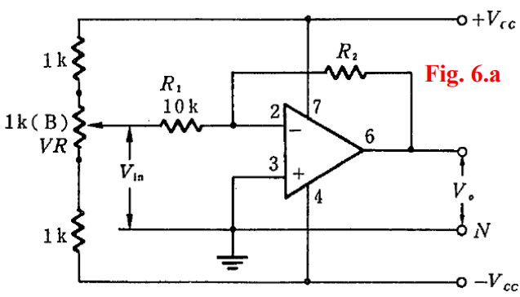

▲ Figure 1. Circuit of Experiment 6.a The Inverting Configuration

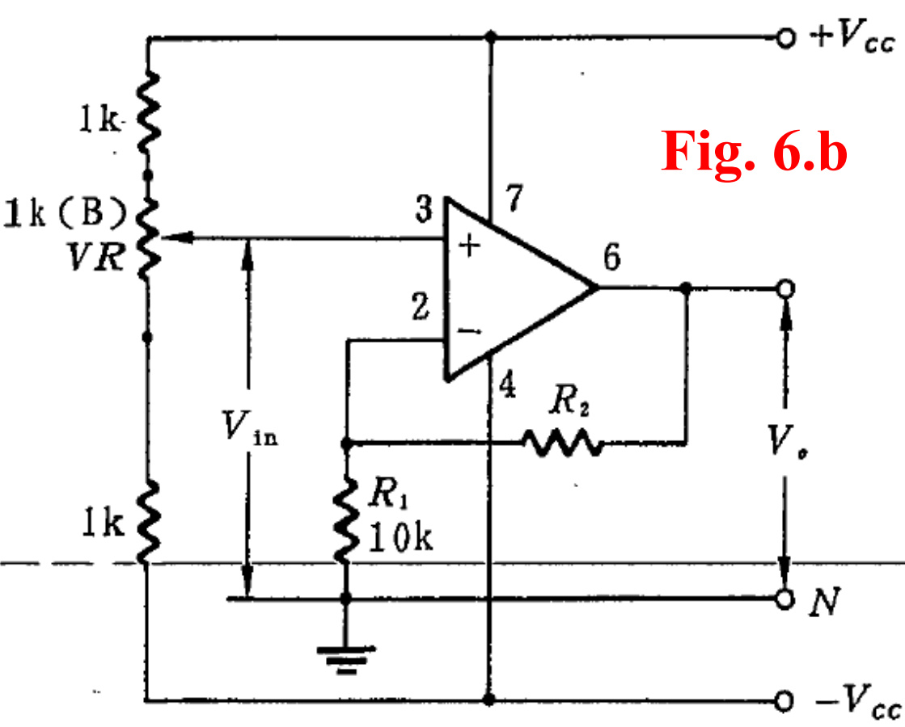

▲ Figure 2. Circuit of Experiment 6.b The Noninverting Configuration

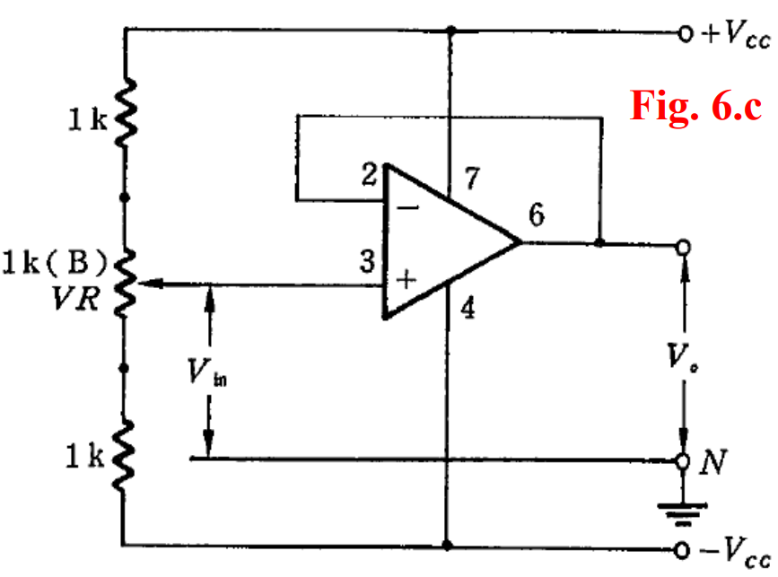

▲ Figure 3. Circuit of Experiment 6.c The voltage follower

1. Methods

Using Digital Multimeter to observe voltage.

1. Experiments data
   1. Experiment 6.a The Inverting Configuration

Table 1: Measurement of Inverting Configuration

|  |  |  |  |  |  |  |  |  |
| --- | --- | --- | --- | --- | --- | --- | --- | --- |
| Vin | -2 V | -1.5 V | -1 V | -0.5 V | 0.5 V | 1 V | 1.5 V | 2 V |
| Vo | 2.0521 V | 1.5394 V | 1.0291 V | 0.5162 V | -0.5131 V | -1.0239 V | -1.5365 V | -2.0498 V |
| Gain | -1.0261 | -1.0263 | -1.0291 | -1.0324 | -1.0262 | -1.0239 | -1.0243 | -1.0249 |

* 1. Experiment 6.b The Noninverting Configuration

Table 2: Measurement of Noninverting Configuration with 10 kΩ

|  |  |  |  |  |  |  |  |  |
| --- | --- | --- | --- | --- | --- | --- | --- | --- |
| Vin | -2 V | -1.5 V | -1 V | -0.5 V | 0.5 V | 1 V | 1.5 V | 2 V |
| Vo | -4.0545 V | -3.0394 V | -2.0256 V | -1.0114 V | 1.0135 V | 2.0272 V | 3.0368 V | 4.0544 V |
| Gain | 2.0273 | 2.0263 | 2.0256 | 2.0228 | 2.0271 | 2.0272 | 2.0245 | 2.0272 |

Table 3: Measurement of Noninverting Configuration with 20 kΩ

|  |  |  |  |  |  |  |  |  |
| --- | --- | --- | --- | --- | --- | --- | --- | --- |
| Vin | -2 V | -1.5 V | -1 V | -0.5 V | 0.5 V | 1 V | 1.5 V | 2 V |
| Vo | -6.0775 V | -4.5722 V | -3.0439 V | -1.5202 V | 1.5192 V | 3.0645 V | 4.5712 V | 6.0856 V |
| Gain | 3.0388 | 3.0481 | 3.0439 | 3.0404 | 3.0384 | 3.0645 | 3.0475 | 3.0428 |

* 1. Experiment 6.c The voltage follower

Table 3: Measurement of voltage follower

|  |  |  |  |  |  |  |  |  |
| --- | --- | --- | --- | --- | --- | --- | --- | --- |
| Vin | -2 V | -1.5 V | -1 V | -0.5 V | 0.5 V | 1 V | 1.5 V | 2 V |
| Vo | -2.0013 V | -1.5118 V | -1.4935 V | -0.5063 V | 0.4989 V | 1.0367 V | 1.5067 V | 2.0188 V |
| Gain | 1.0007 | 1.0079 | 1.4935 | 1.0126 | 0.9978 | 1.0367 | 1.0045 | 1.0094 |

1. Results

None

1. Discussion
   * 1. What are the values of the open loop voltage gain, input impedance and output impedance for an ideal OPAmp?

**Open Loop Voltage Gain (A)**: For an ideal op amp, the open-loop gain is considered to be infinite. This means that even a very small voltage difference between the input terminals results in a very large output voltage.

**Input Impedance**: The input impedance of an ideal op amp is infinite, which means it draws virtually no current from the preceding stage.

**Output Impedance**: The output impedance of an ideal op amp is zero, allowing it to drive loads without any loss in voltage across the output due to the current drawn by the load.

* + 1. What is the meaning for the input terminal “+” of an ideal OPAmp?

The "+" input terminal of an op amp is known as the non-inverting input. When a voltage is applied to this terminal, it results in an output voltage that is in phase with the input voltage. Increasing the voltage at the "+" input relative to the "-" input increases the output voltage.

* + 1. What is the meaning for the input terminal “-” of an ideal OPAmp?

The "-" input terminal is known as the inverting input. Unlike the non-inverting input, any voltage increase at this terminal results in a decrease in the output voltage, i.e., the output voltage is 180 degrees out of phase with the input voltage applied at this terminal.

* + 1. If an OPAmp circuit has a negative feedback (i.e., the output is connected to the input terminal “-” in a way) configuration, what is the voltage difference between the input terminal “+” and the input terminal “-” ?

In a negative feedback configuration, the ideal voltage difference between the input terminals "+" and "-" (known as the differential input voltage) is zero. This condition is often referred to as the virtual short concept, which implies that the op amp works to adjust the output to ensure that there is no voltage difference across the input terminals despite any external influences.

* + 1. What are the advantages using ICs for building electronic circuits?

**Size and Weight Reduction**: ICs are compact and lightweight, which allows for the development of smaller and more portable electronic devices.

**Increased Reliability**: Fewer interconnections and soldered joints mean there are fewer points of failure, which enhances the reliability of the circuits.

**Cost Efficiency**: Mass production of ICs makes them cheaper per unit compared to discrete components. This reduces the overall cost of electronic products.

**Improved Performance**: ICs can operate at higher speeds and with greater efficiency due to their small size and reduced electrical resistance and capacitance.

**Ease of Assembly**: ICs simplify the assembly process of electronic devices by reducing the number of components that need to be handled and placed on the circuit board.

1. Conclusion

From the experimental data above, the operational amplifiers work in an ideal situation.